JUNETEENTH BOARD of DIRECTORS
President: Susannah Johnson Malbreaux
Vice President: Brenda Andrus
Secretary: Natalie Spencer
Treasurer: Karen Miller
Past President: Abram Freeman
December 11, 2023

Dear Potential Sponsor:
Juneteenth, also known as “Freedom Day” or “Emancipation Day”, commemorates the announcement of the abolition of slavery in Texas on June 19th, 1865 by General Gordon Granger. Juneteenth is celebrated to commemorate the ending of slavery in the United States by celebrating the joys of liberty, educating the community about our heritage and by promoting positive cultural interaction. For more information, please visit our website: www.swlajuneteenth.org or the National Juneteenth website: http://nationaljuneteenth.com.
The Juneteenth Holiday/Celebration is a special day our country has been a holiday in Louisiana since 2005 and a National Holiday as of 2021.
In an effort to continue the tradition of uniting the community, we are asking for your help in supporting this effort. A tax deductible contribution toward this worthwhile event will ensure the success and continuance of this community uniting celebration. All donations, large and small are welcome; however, the Juneteenth Sponsorship Form details benefits in consideration of your level of donation.
Will you make a commitment to help make a difference in our community? Please do not hesitate to contact Susannah Johnson Malbreaux at (337) 212-1950 or email to contact@swlajuneteenth.org. The SWLA Juneteenth Committee thanks you in advance for your time and consideration and we look forward to working with you.

Sincerely,

SWLA Juneteenth Committee
2024 JUNETEENTH SPONSORSHIP LISTING
PARTNER: $5,000
- Logo on every webpage of SWLA Juneteenth Website (Up to 400 views + per month)
- Name or Logo on every PSA and Paid (TV, Radio, Print)
- Name or Logo on Banner in front at Gate Entrance
- Five (5) minute presentation at Festival
- Free table at Festival and Juneteenth Pins
- Name/Logo on Stage as Presenting Sponsor
ADVOCATE: $2,500
- Logo on home and sponsors page of website (Up to 400 views + per month)
- Name or Logo on every PSA and Paid (TV, Radio, Print)
- Banner Displayed at festival and Juneteenth Pins
- Verbal thank you with a message about product or services
SUPPORTER: $1,500
- Logo on sponsors page of website (Up to 400 views + per month)
- Name or Logo on every PSA (TV, Radio, Print)
- Banner Displayed at festival and Juneteenth Pins
- Verbal thank you for support throughout the festival

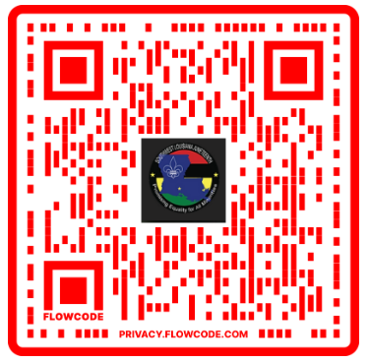
Marketing sponsors includes the largest radio market, CUMULUS Media, KIEE the local market, Lafayette Parish Government, The Senior Pastoral Alliance and many other cities, magazines, chambers and groups as well as partnerships with Schilling Distribution and several digital and print media outlets. Finally the Lafayette Tourism is fully charged to grow our events.

2024 Sponsor Commitment Form
Dear SWLA Juneteenth Committee:
We will help in supporting the 2024 Juneteenth Celebration for Southwest Louisiana. We make a commitment of a tax-deductible donation in the amount of:
Please choose one of the following:
_______ $5,000 as a Partner
______ $2,500 as an Advocate
_______ $1,500 as a Supporter
_______ $ 2800 as a sponsor the Sickle Cell Anemia Walk on June 19th from 7-9 AM

Company Name: _______________________________________________________________
Address: _____________________________________________________________________
City: _____________________________State: __________ Zip Code: ______________
Phone: ___________________________ Email: ___________________________________
Contact Person: ________________________________________________________________
Please fax form to: Fax: (337) 326-4761
Please Mail Payment (Check or Money Order) to:
SWLA Juneteenth Committee
P.O. Box 63061; Lafayette, LA 70596
Or Call (337) 212-1950 for more information.

