JUNETEENTH BOARD
President: Susannah Johnson Malbreaux
Vice President: Brenda Andrus
Secretary: Natalie Spenser
Treasurer: Karen Miller
Past President: Abram Freeman

Dear Potential Member:
Juneteenth, also known as “Freedom Day” or “Emancipation Day”, commemorates the announcement of the abolition of slavery in Texas on June 19th, 1865 by General Gordon Granger. Juneteenth is celebrated to commemorate the ending of slavery in the United States by celebrating the joys of liberty, educating the community about our heritage and by promoting positive cultural interaction. For more information, please visit our website: www.swlajuneteenth.org or the National Juneteenth website: http://nationaljuneteenth.com.
The Juneteenth Holiday/Celebration is a special day our country has been a holiday in Louisiana since 2005 and a National Holiday as of 2021.
In an effort to continue the tradition of uniting the community, we are asking for your help in supporting this effort. A tax deductible contribution toward this worthwhile event will ensure the success and continuance of this community uniting celebration. All donations, large and small are welcome; however, the Juneteenth Sponsorship Form details benefits in consideration of your level of donation.
Will you make a commitment to help make a difference in our community? Please do not hesitate to contact Susannah Johnson Malbreaux at (337) 212-1950 or email to contact@swlajuneteenth.org. The SWLA Juneteenth Committee thanks you in advance for your time and consideration and we look forward to working with you.

Sincerely,

SWLA Juneteenth Committee
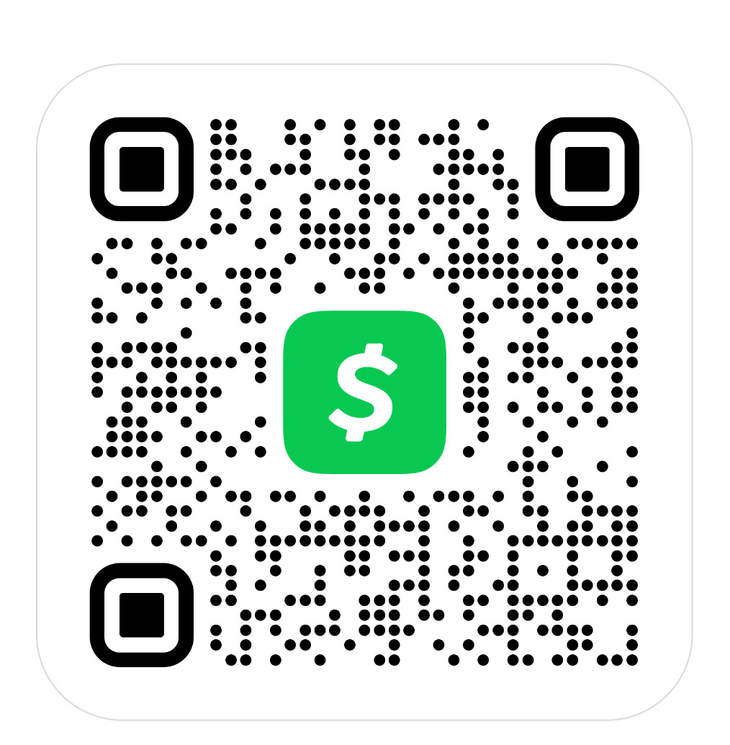

SWLA Juneteenth 2024 Upcoming Events

- SWLA Juneteenth presents Essay / Poster Contest - April 01 - June 01, 2024

- Friday, June 14, 2024; The Juneteenth Story 2pm and 7pm, Acadiana Center for the Arts, 101 W. Vermilion St., Lafayette, LA

- Saturday, June 15, 2024; The Juneteenth Story 2pm and 7pm, Acadiana Center for the Arts, 101 W. Vermilion St., Lafayette, LA

- Sunday, June 16, 2024; The Juneteenth Story 2pm and 7pm, Acadiana Center for the Arts, 101 W. Vermilion St., Lafayette, LA

- Tuesday, June 18, 2024; 40 Acres and a Mule – Downtown Convention Center, 124 S. Buchanan Street, Lafayette, LA

- Wednesday, June 19, 2024 - Juneteenth Opening Ceremonies & Flag Raising, Lafayette Consolidated Government, 705 West University Avenue, Lafayette, LA

- Wednesday, June 19, 2024 - Juneteenth Celebration ~ Lyrical Healing-Open Mic 5:30-7:30pm, Historic Heymann Park, 1500 S Orange St, Lafayette, LA

- Thursday, June 20, 2024; Move the Mindset; Juneteenth Commemoration; 6pm – 8:30pm, Downtown Convention Center, 124 Buchanan St. Lafayette, LA

- Friday, June 21, 2024 - Juneteenth Banquet / Pageant; 6:30pm-9:30pm, Downtown Convention Center, 124 Buchanan St. Lafayette, LA

- Saturday, June 22, 2024, Evening - Juneteenth Festival; - 4:30pm-8:30pm – Historic Heymann Park, 1500 S Orange St, Lafayette, LA

LIKE OUR FB PAGE: SWLA Juneteenth (Lafayette) | Facebook

2024 JUNETEENTH MEMBERSHIP LEVELS & COMMITMENT FORM
Dear SWLA Juneteenth Committee:
I will help in supporting the 2024 Juneteenth Celebration for Southwest
Please choose one of the following:
MEMBERSHIP
- Platinum Level $200 – Two tickets to banquet and play (preferred seating) two T-shirts & 2 Juneteenth Pins________________
- Gold Level $125 - One ticket to banquet and play (preferred seating) one T-shirt and 1 Juneteenth Pin ________________
- Silver Level $100 - One ticket to banquet and play, one T-shirt and 1 Juneteenth Pin ________________
- Bronze Level $75 - One ticket to banquet, one T-shirt and 1 Juneteenth Pin ________________

I will make a commitment of a tax-deductible donation in the amount (Circled Above)

Name: _______________________________________________________________________
Address: _____________________________________________________________________
City: _____________________________State: __________ Zip Code: ______________
Phone: ___________________________ Email: ___________________________________
Contact Person: ________________________________________________________________
Please Mail Payment (Check or Money Order) & Form to:
SWLA Juneteenth Committee
P.O. Box 63061
Lafayette, LA 70596

Cash App to: https://cash.app/$swlajuneteenth
Call (337) 212-1950 for more information.

